Care of Green Tree Frogs(*Hyla cinerea*)

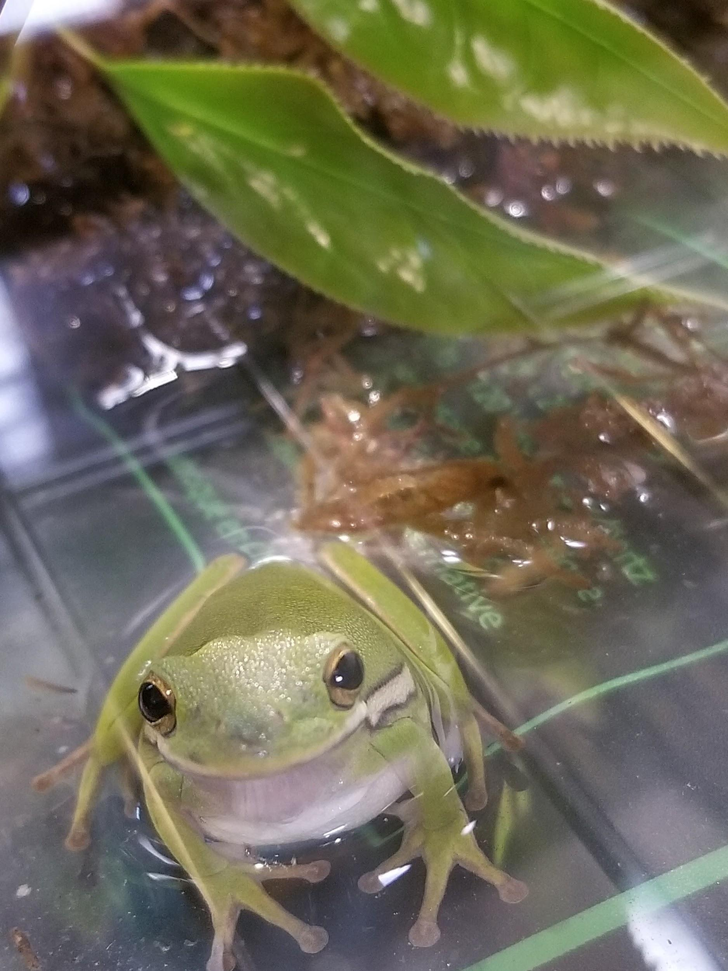

The Green Tree Frog or its scientific name *Hyla cinerea* is commonly found in many parts of the United States. It is an arboreal frog but can be found burrowing in dead plant material on the ground. These frogs are nocturnal so they are most active at night but will still move around and feed during the day. They can survive up to 10 years with proper care. All protocols and procedures follow recommendations from the [NIH Guide for Care and Use of Laboratory Animals](https://grants.nih.gov/grants/olaw/guide-for-the-care-and-use-of-laboratory-animals.pdf) where appropriate.

**Temperature and Humidity**

The frogs should be kept at a temperature ranging from 65F - 85F(20C - 30C). With a temperature around 75F(24C) best. It is ok for temperature at night to drop down to the lower end of the range. These frogs need humidity and water but they are not aquatic. It is best to keep a small water bath in the cage for the frogs and also line part or all of the bottom of the cage with moss or shredded coconut husk because it can hold water and the frogs will not try and eat it. Water the moss or coconut husk at least once a week. Make sure the water is treated if tap water or unchlorinated.

**Water**

All tap water must be treated. Follow the instructions for the amount of water treatment to add to the tap water. Generally, you can’t add too much(though don’t go overboard) and the water becomes dechlorinated in minutes.

**Feeding**

These frogs eat mostly living insects and worms. Crickets and roaches are a great food source. Feed the frogs every 2 days depending on the number of frogs and the size of the frogs. Bigger frogs can go longer without food.

**Determining the Sex**

Tree frogs are notoriously difficult to sex. Males often have a pouchy neck and “sing”(though on rare occasions females have been known to sing). The singing sounds like a teeny dog barking.

**Habitat**

Habitats need to be completely enclosed as Green Tree frogs are great climbers and jumpers. If possible include sticks and branches with leaves attached for the frogs to climb and hide on. These frogs can stick to the side of their enclosure and will often climb up the side and stay near the top.

**Anesthesia and Euthanasia**

In order to anesthetize these frogs you need to let them sit in 0.04%(400mg / liter) benzocaine usually by placing them in a mason jar or small container. This can take 10-20 minutes depending on how much of their skin is in contact with the liquid. Be careful not to let the frogs stay unconscious in the liquid for too long as they can die. After the frogs become unconscious move them to a clean container with a minimal amount of water on the bottom(it should not cover their face or head). Frogs usually recover in 30 minutes - 1 hour but in some instances can take up to 4 hours or more. If a frog is severely injured you can keep it submerged in the 0.04% benzocaine solution for 2 hours or more and it will not recover consciousness.